Create a React Application named “cricketapp” with the following components:

1. ListofPlayers

* Declare an array with 11 players and store details of their names and scores using the map feature of ES6
* Filter the players with scores below 70 using arrow functions of ES6.

ListOfPlayers.js

import React from 'react';

const ListOfPlayers=() =>{

    const players=[

        {name: 'Jack',score:50},

        {name: 'Michael',score:70},

        {name:'Jhon',score: 40},

        {name: 'Ann',score: 61},

        {name: 'Elisabeth', score: 61},

        {name: 'Sachin', score: 95},

        {name: 'Dhoni', score: 100},

        {name: 'Virat', score: 84},

        {name: 'Jadeja', score: 64},

        {name: 'Raina', score: 75},

        {name: 'Rohit', score: 80},

    ];

    const seventy=players.filter(player => player.score<70);

    return(

        <div><h2>List Of Players</h2>

            <ul>

                {players.map(item => (

                    <li key={item.name}>

                        Mr . {item.name} <span>{item.score}</span>

                    </li>

                ))}

            </ul>

            <hr />

            <h2>List Of Players having Score Less than 70:</h2>

            <ul>

                {

                    seventy.map(item => (

                        <li key={item.name}>

                            Mr . {item.name} <span>{item.score}</span>

                        </li>

                    ))

                }

            </ul>

        </div>

    );

    };

export default ListOfPlayers;

2 . IndianPlayers

* Display the Odd Team Player and Even Team players using the Destructuring features of ES6.
* Declare two arrays T20players and RanjiTrophy players and merge the two arrays and display them using the Merge feature of ES6

IndianPlayers.js

import React from 'react';

const IndianPlayersComponent = () => {

    const team = ['Sachin1','Dhoni2','Virat3','Rohit4','Yuvaraj5','Raina6'];

    const [first,third,fifth]=team;

    const [second,fourth,sixth]=team;

    const T20Players=['First Player','Second Player','Third Player'];

    const RanjiTrophyPlayers = ['Fourth Player','Fifth Player','Sixth Player'];

    const mergerdPlayers = [...T20Players,...RanjiTrophyPlayers];

    return(

        <div>

            <h2>ODD PLAYERS</h2>

            <ul>

                <li>First: {first}</li>

                <li>Third: {third}</li>

                <li>Fifth: {fifth}</li>

            </ul>

            <hr />

            <h2>EVEN PLAYERS</h2>

            <ul>

                <li>Second: {second}</li>

                <li>Fourth: {fourth}</li>

                <li>Sixth: {sixth}</li>

            </ul>

            <hr />

            <h2>LIST OF INDIAN PLAYERS MERGED:</h2>

            <ul>

                {mergerdPlayers.map((Player,index) => (

                    <li key={index}>Mr . {Player}</li>

                ))}

            </ul>

        </div>

    );

};

export default IndianPlayersComponent;

App.js

import React from 'react';

import ListOfPlayers from './ListofPlayers/listofplayers';

import IndianPlayersComponent from './IndianPlayers/indianplayers';

const App = () => {

  const flag = true;

  const players = [

    { name: 'Jack', score: 50 },

    { name: 'Michael', score: 70 },

    { name: 'Jhon', score: 40 },

    { name: 'Ann', score: 61 },

    { name: 'Elisabeth', score: 61 },

    { name: 'Sachin', score: 95 },

    { name: 'Dhoni', score: 100 },

    { name: 'Virat', score: 84 },

    { name: 'Jadeja', score: 64 },

    { name: 'Raina', score: 75 },

    { name: 'Rohit', score: 80 },

  ];

  const IndianTeam = ['Sachin1', 'Dhoni2', 'Virat3', 'Rohit4', 'Yuvaraj5', 'Raina6'];

  const T20players = ['Mr. First Player', 'Mr. Second Player', 'Mr. Third Player'];

  const RanjiTrophyPlayers = ['Mr. Fourth Player', 'Mr. Fifth Player', 'Mr. Sixth Player'];

  const mergedPlayers = [...T20players, ...RanjiTrophyPlayers];

  return (

    <div>

      {flag ? (

        <div>

          <ListOfPlayers players={players} />

        </div>

      ) : (

        <div>

          <IndianPlayersComponent players={IndianTeam} mergedPlayers={mergedPlayers}/>

        </div>

      )}

    </div>

  );

};

export default App;

Execution of code:

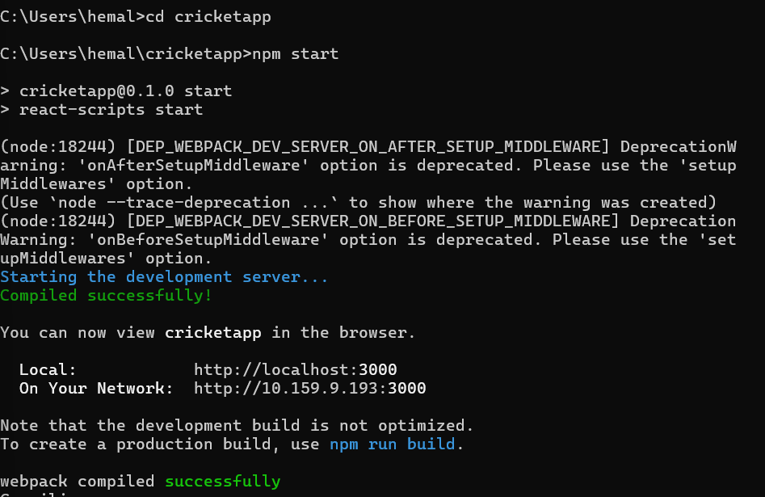

Output:

When flag=true

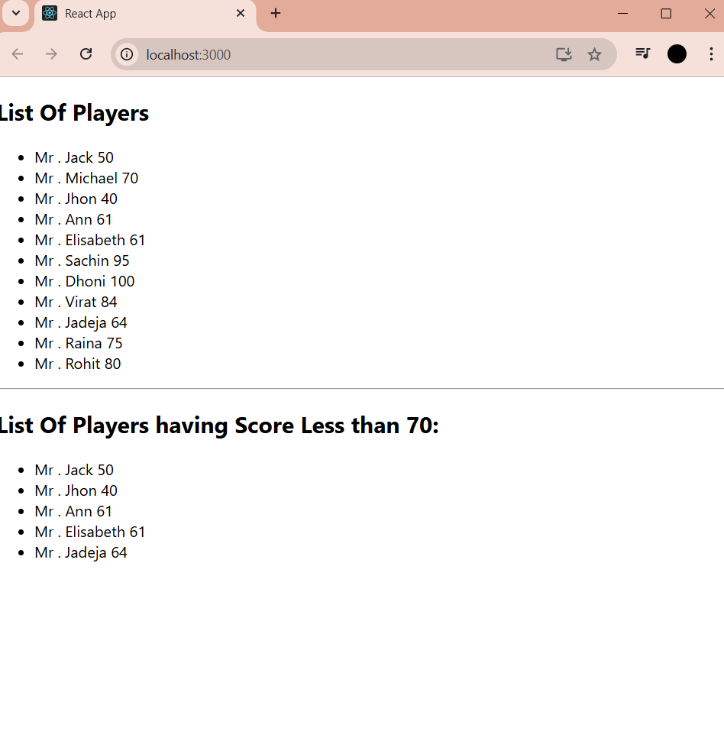

When flag=false

